# More exercises: HTML Landing Pages and Forms

Problems for exercises and homework for the ["HTML and CSS" course @ SoftUni](https://softuni.bg/courses/web-fundamentals-html5). Submit your solutions in the SoftUni judge system at [https://judge.softuni.bg/Contests/410/HTML-](https://judge.softuni.bg/Contests/410/HTML-Forms-and-Styling)Landing-Pages-and-Forms-More-Exercises .

## Product Form

Create a Web page (HTML5 + CSS3 + images) that looks and behaves like the screenshots below:

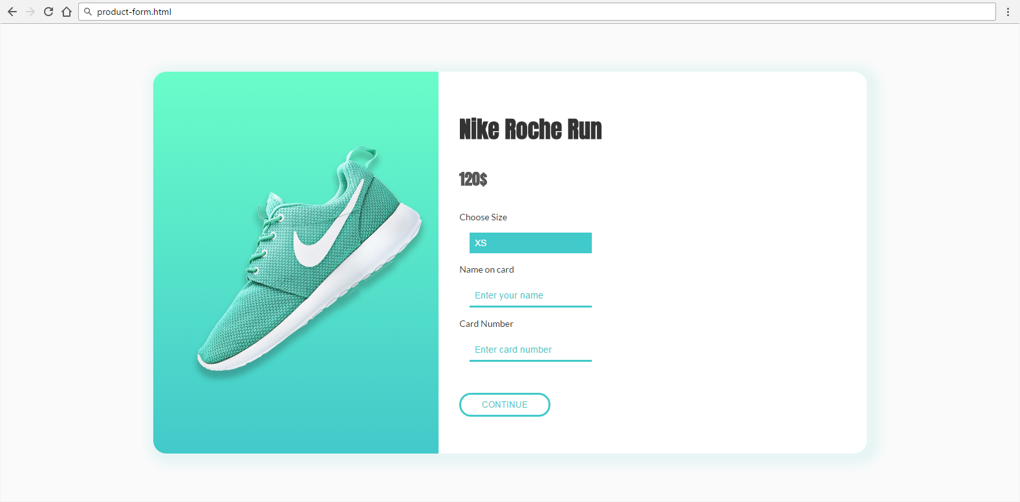

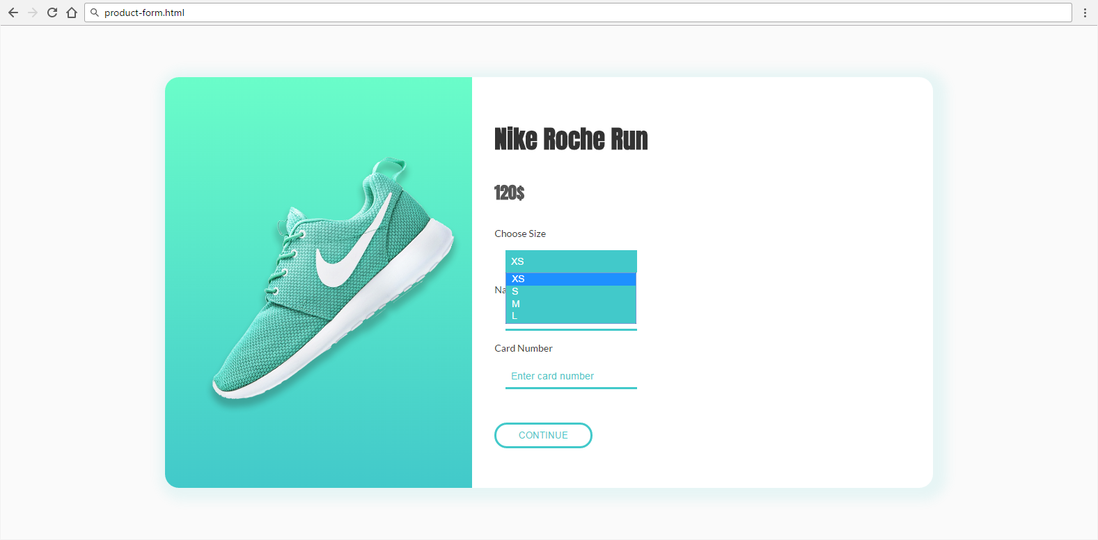

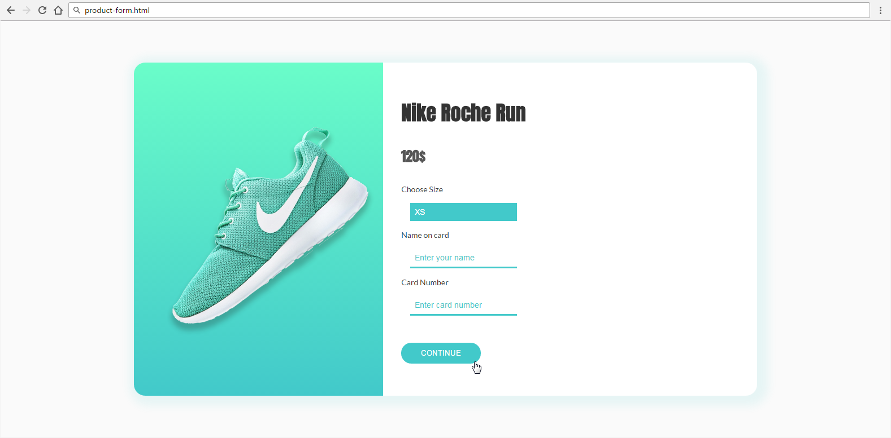

* The mouse cursors in the above screenshots explain what happens when the mouse moves over a project or a group.

### Input

You are given the above screenshots + all required images + the texts on the site.

### Output

The output should be valid HTML5 + CSS3 + images that implement the above Web page.

### Constraints

* Font: 14px 'Lato', sans-serif.
  + <https://fonts.googleapis.com/css?family=Lato:400,700>
  + <https://fonts.googleapis.com/css?family=Anton>
* Background gradient: linear-gradient(to bottom, #6afdc9 0%,#42c9ca 100%)
* Form validation is not required.
* Responsive design is not required.
* Pixel-perfect implementation is not required.
* Take the colors from the pictures with color picker.

## Room Reservation

Create a Web page (HTML5 + CSS3 + images) that looks and behaves like the screenshots below:

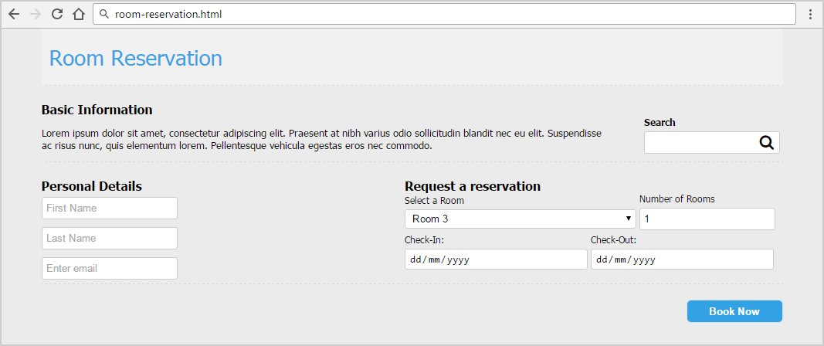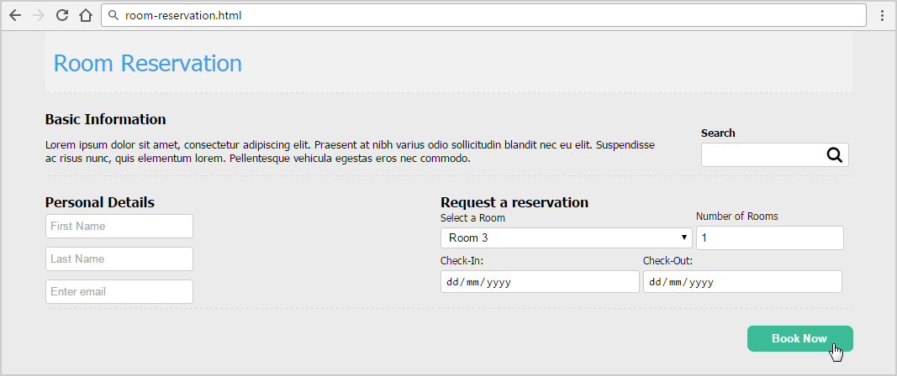

* The mouse cursors in the above screenshots explain what happens when the mouse moves over a project or a group and when the browser window resizes.

### Input

You are given the above screenshots + all required images + the texts on the site.

### Output

The output should be valid HTML5 + CSS3 + images that implement the above Web page.

### Constraints

* Font: 13px Tahoma, Helvetica, sans-serif.
* Title: 28px; Subtitle: 16px; Tahoma, Helvetica, sans-serif.
* “Select a room” is drop-down.
* “Number of rooms” is number field.
* “Check-in” and “Check-out” are date fields.
* Other fields are text.
* Form validation is not required.
* Responsive design is not required.
* Pixel-perfect implementation is not required.
* Take the colors from the pictures with color picker.

## Free Account

Create a Web page (HTML5 + CSS3 + images) that looks and behaves like the screenshots below:

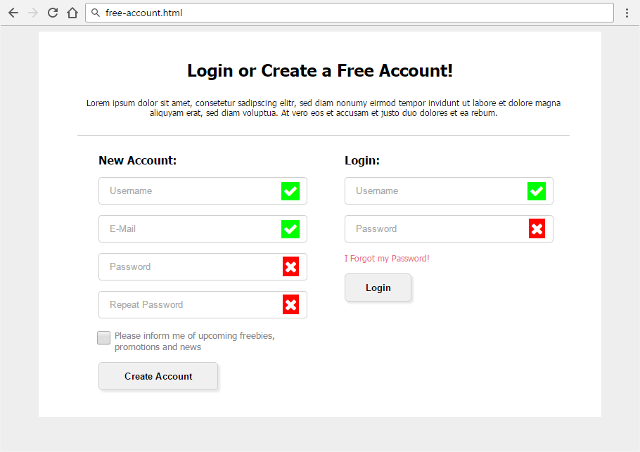

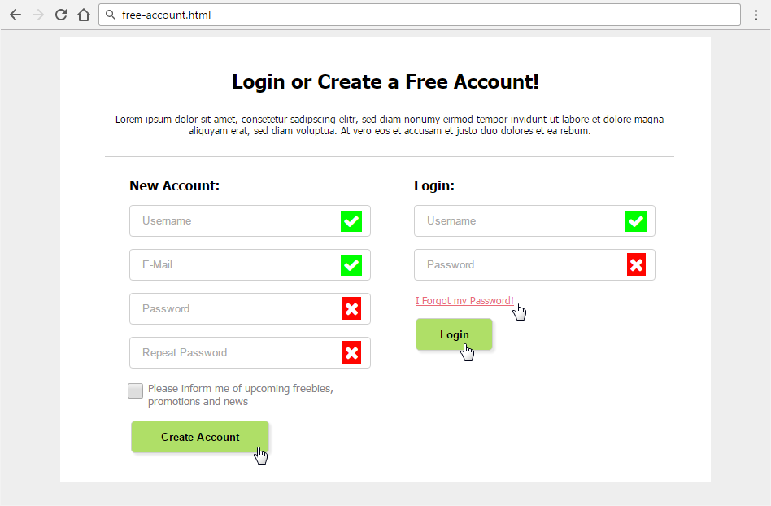

* The mouse hand-pointers and the bottom bar in the screenshots are not part of your page, so please skip them.

### Input

You are given the above screenshots and all required images.

### Output

The output should be valid HTML5 + CSS3 + images that implement the above Web form.

* You do not need to implement form validation.

### Constraints

* Font: Tahoma, Helvetica, sans-serif.
* Site content: fixed width 800px.
* Heading font-size: 24px.
* Form validation is not required.
* Responsive design is not required.
* Pixel-perfect implementation is not required.
* Icons from FontAwesome: content: '\f00c'; content: '\f00d'**;**
* Take the colors from the pictures with color picker.

## Edit User Form

Create a Web page (HTML5 + CSS3 + images) that looks and behaves like the screenshots below:

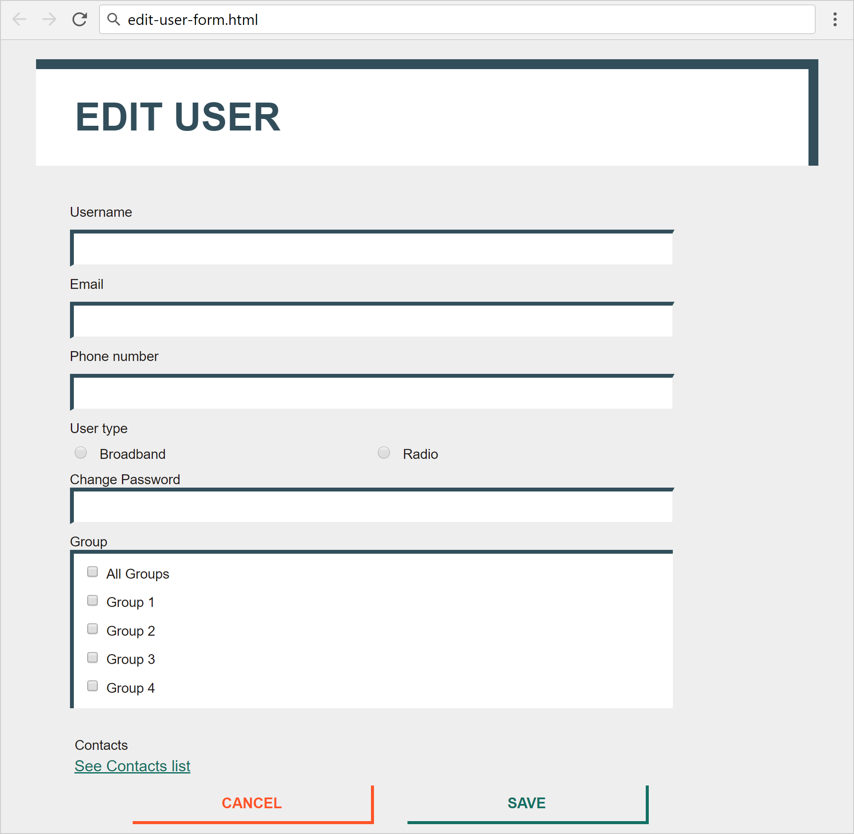

* The mouse hand-pointers and the bottom bar in the screenshots are not part of your page, so please skip them.

### Input

You are given the above screenshots + the images for the news items + the texts on the site.

### Output

The output should be valid HTML5 + CSS3 + images that implement the above Web page.

### Constraints

* Font: 16px "Roboto", Helvetica, sans-serif;
* <https://fonts.googleapis.com/css?family=Roboto:400,500,700>
* Default text: #1E1917;
* Title: 40px;
* Labels: 14px/500;
* Buttons font-size: 15px/700;
* Link: #136F63, 15px, no-hover effect
* Content max-width: 800px;
* Form validation is not required.
* Responsive design is not required.
* Pixel-perfect implementation is not required.